Bahria University,

Karachi Campus



LAB EXPERIMENT NO.

_______6_______

LIST OF TASKS

|  |  |
| --- | --- |
| TASK NO | OBJECTIVE |
| 1 | **Using python implements VADER rules-based classification algorithm to find the sentiments of different sentences.** |
| 2 | **Using python implements textBlob rules-based classification algorithm to find the sentiments of different sentences and compare the results with task # 01.** |

Submitted On:

___________

(Date: 9/5/23)

**LAB # 06**

**Task # 1: Using python implements VADER rules-based classification algorithm to find the sentiments of different sentences.**

**Solution:**

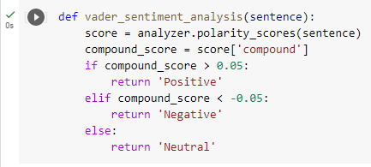

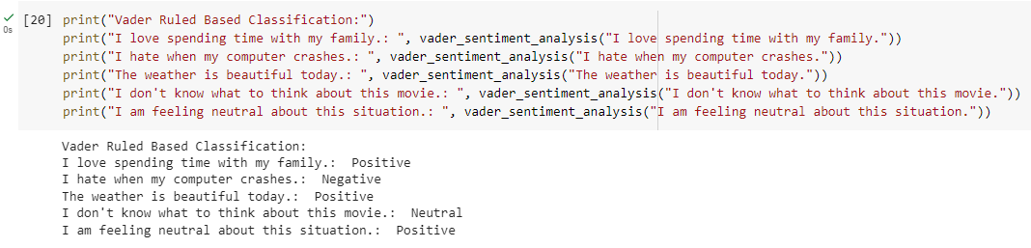

**Task # 2: Using python implements textBlob rules-based classification algorithm to find the sentiments of different sentences and compare the results with task # 01.**

**Solution:**

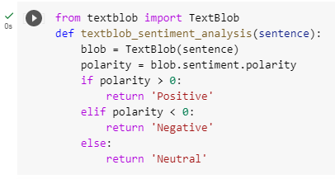

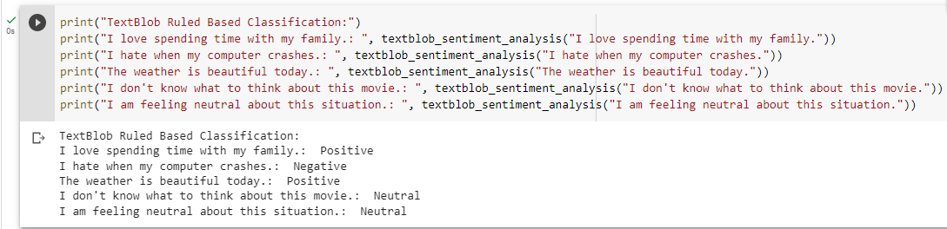

**Comparison:**

